Basic Bronchoscopy Boot Camp MCQs, 2026

Question 1
A right lower lobe transbronchial lung biopsy is performed for evaluation of a peripheral lower lobe lung mass. The final sample resulted in a large piece and brisk bleeding from the target segmental airway. Which of the following is the MOST APPROPRIATE maneuver at this point?
A. Wedge the bronchoscope within the segmental bronchus
B. Instill 2 ml of topical epinephrine within the lobar bronchus
C. Place the patient in right lateral decubitus position
D. Intubate the patient with a single-lumen large-bore endotracheal tube
Correct answer: A. Wedge the bronchoscope within the segmental bronchus

Answer explanation
Brisk bleeding after transbronchial biopsy is managed first by isolating the bleed from the rest of the respiratory tree. The fastest bronchoscopic maneuver is to wedge the bronchoscope into the bleeding segmental bronchus. This provides local tamponade and limits blood spillover and potential compromise of gas exchange.
Topical epinephrine or iced saline can be useful, but instilling medication into the lobar bronchus before isolating the segment delays the most important first step. Also, small volume epinephrine is unlikely to reach the peripheral site of bleeding, and this approach is better suited for endobronchial and visible mucosal bleeds. Dependent positioning can help after the bleeding side is identified, but it does not immediately tamponade the target airway.
A single-lumen large-bore endotracheal tube may be needed if the situation becomes more emergent and/or if initial therapies, but this step can be prevented in a large majority of cases by simple isolation of the bleeding segment by wedge. After wedging for 30-120 seconds, the operator reassesses and escalates as needed to iced saline, vasoactive agents, tranexamic acid, balloon blockade, advanced local therapy, or embolization.

Question 2
What is the airway represented at the 9-o'clock position in this picture?
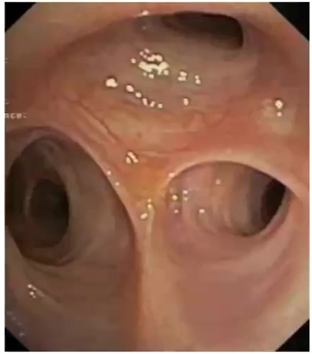
A. The anterior segmental bronchus of the right upper lobe
B. The bronchus intermedius
C. The lateral segmental bronchus of the lingula
D. The posterior basilar segmental bronchus of the right lower lobe
Correct answer: A. The anterior segmental bronchus of the right upper lobe

Answer explanation
The image shows the right upper lobe trifurcation, often remembered as the reverse Mercedes sign. The orientation seen in the question stem is the most commonly encountered when entering the right upper lobe bronchus and the 9-o'clock airway (anterior aspect of the patient) is the anterior segmental bronchus.
The bronchus intermedius lies distal to the right upper lobe takeoff and leads toward the right middle and lower lobes. The lingula is part of the left upper lobe, and the posterior basilar segment belongs to the right lower lobe, so neither fits this trifurcation.
General tips: Scope rotation can change what appears left or right on screen, so the branch pattern and nearby landmarks should be used together. Also, a useful mental check is to name the lobe first, then the segmental pattern. The right upper lobe has apical, anterior, and posterior segmental bronchi; the right middle lobe two segments (medial and lateral), the lower lobe has a superior and 4 basilar segments (medial, anterior, lateral, posterior). The left upper lobe includes the superior division, with 2 segments (apicoposterior and anterior), and the lingula with two segments (superior, inferior). The left lower lobe is similar to the right lower lobe, except the medial and anterior basilar segments are combined into an anteromedial segment.

Question 3
You are called by the bedside ICU nurse and respiratory therapist for worsening airway pressures in a mechanically ventilated patient with right pneumonia. Ten minutes prior, suctioning for copious mucus caused minor bleeding that resolved. The patient is mildly sedated, ventilator tubing is patent, a size 8.0 endotracheal tube is present, peak airway pressure is 60 cm H2O, static end-inspiratory pressure is 19 cm H2O, SpO2 is 88%, and end-tidal CO2 has increased. A STAT bronchoscopy is planned. Which of the following is MOST appropriate for the procedure in this situation?
A. Switch to pressure-control mode, capping peak inspiratory pressure at 30 mm Hg
B. Utilize an outer diameter 6.0 and working channel 2.8 mm bronchoscope
C. Maintain FiO2 at 50% to avoid oxygen toxicity.
D. Minimize sedation and/or antitussives to prevent cardiorespiratory collapse
Correct answer: B. Utilize an outer diameter 6.0 and working channel 2.8 mm bronchoscope

Answer explanation
The key ventilator clue is a very high peak pressure with a normal static end-inspiratory pressure. That pattern points to increased airway resistance, such as mucus plugging, tube obstruction, bronchospasm, or airway narrowing, rather than reduced lung compliance.
Bronchoscopy through an endotracheal tube can worsen airway resistance and gas exchange. Appropriate preparation includes preoxygenation, adequate sedation or antitussive therapy, and choosing a bronchoscope small enough to preserve ventilation through the size 8.0 tube while still allowing effective suction. A rough rule is to choose a bronchoscope with an outer diameter ~2mm small than the inner diameter of the existing airway. In this case, the therapeutic scope described in option B matches the needs of this case well.
Switching to pressure-control mode and capping inspiratory pressure is not appropriate here because the obstructed system would likely receive a much lower tidal volume. In a patient already hypoxemic and retaining CO2, that will likely worsen ventilation rather than solve the resistance problem, and potentially lead to cardiac arrest if the procedure is prlonged.
The bronchoscope itself partially occludes the endotracheal tube, so the preprocedure plan should preserve the largest possible annular space around the scope. Close communication with the respiratory therapist is essential: monitor tidal volume, pressure alarms, oxygen saturation, and CO2 while suctioning the obstruction efficiently. The interaction should be dynamic and the bronchoscopist should stop if saturation or tidal volume decrease significantly or for a prolonged period, withdraw the scope to re-establish ventilation, and re-enter only when the patient can tolerate further airway maneuvers.

Question 4
A young, previously healthy adult patient is hospitalized for aspiration of a foreign body. She reports a sudden choking and coughing sensation while laughing and eating grapes a few hours before presentation. She is comfortable, occasionally coughs and clears her throat, has normal vital signs, and has focal right-sided high-pitched bronchial sounds. Chest CT confirms a round, smooth, hypodense object impacting the proximal right lower lobe bronchus with distal segmental atelectasis. Of the choices listed, which is the MOST APPROPRIATE approach to extracting this foreign body?
A. Rigid bronchoscopy under general anesthesia, utilizing large rigid forceps
B. Flexible bronchoscopy under general anesthesia, endotracheal tube, utilizing flexible smooth cup forceps
C. Flexible bronchoscopy under moderate sedation, endotracheal tube, utilizing cryoprobe
D. Flexible bronchoscopy under moderate sedation, no artificial airway, utilizing snare-basket
Correct answer: D. Flexible bronchoscopy under moderate sedation, no artificial airway, utilizing snare-basket

Answer explanation
Important factors to consider for planning foreign body extraction, are characteristics of the object itself (size, shape, organicity) and the clinical presentation (patient status, timeframe of the aspiration). This is a stable, healthy adult with a smooth, round, organic foreign body lodged beyond the central airway, presumably an acutely aspirated grape given the clinical history. A snare-basket is well suited for extraction in this case because it can encircle and seize the object. A grape is compressible, smooth, and slippery; a basket can surround it, whereas forceps may crush or lose it. While an endotracheal tube helps protect the vocal cords from sharp objects, it can limit removal of a larger materials through the airway, and a grape large enough to lodge in the proximal lower lobe bronchus may have difficulty traversing the tube, regardless of the tools used.
Rigid bronchoscopy under general anesthesia is important for unstable patients, central airway obstruction, pediatric foreign bodies, large or sharp objects, in chronic aspiration when destruction of granulation tissue and other salvage methods may be needed to free the foreign body, or failed flexible extraction.
In summary, flexible bronchoscopy without an artificial airway is the best initial approach for the specific scenario presented, as the others are either inappropriate or unnecessary. As with any foreign body extraction, the operator should still be prepared to escalate to general anesthesia, rigid bronchoscopy, or airway control if the object migrates, fragments, or causes respiratory compromise.

Question 5
Upon completion of a bronchoalveolar lavage while targeting moderate sedation in a patient with suspected atypical infection, the airway findings shown below are noted. How are these findings best described?
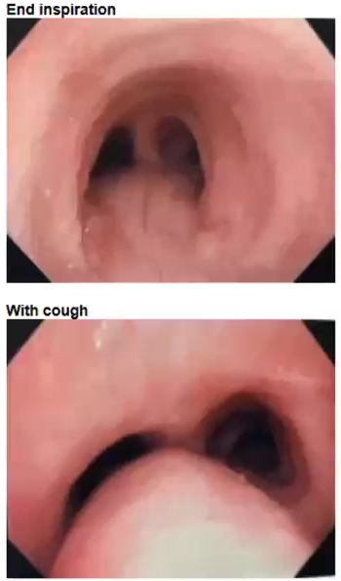
Airway at end inspiration and during cough.
A. Intrinsic invasion of the trachea by tumor
B. Extrinsic compression of the trachea by tumor
C. Saber-sheath trachea
D. Dynamic airway collapse
Correct answer: D. Dynamic airway collapse

Answer explanation
The paired images compare end inspiration with coughing. The airway is relatively open at end inspiration but narrows markedly posteriorly during cough, which is the hallmark of dynamic airway collapse rather than a fixed lesion.
Intrinsic tumor invasion usually produces an endoluminal mass, mucosal disruption, or focal fixed narrowing. Extrinsic compression from tumor would result in constant indentation from outside the airway. Saber-sheath trachea is a fixed tracheal shape abnormality, not a cough-induced collapse pattern.
Dynamic airway collapse or tracheobronchomalacia can be exaggerated by coughing, forced exhalation, and sedation. During bronchoscopy, the location and severity should be documented, and management should be based on symptoms, comorbid disease, and response to airway-supportive measures. The finding is often incidental, but it can explain cough, wheeze, secretion retention, or difficulty weaning from ventilation.

Question 6
Which of the following is the MOST CORRECT description of bronchoscope anatomy and/or function?
A. A therapeutic bronchoscope is defined by its outer diameter
B. Single-use disposable bronchoscopes are more financially costly for a bronchoscopy practice than reusable scopes
C. Angulation of scope flexion exceeds that of scope extension
D. A convex-probe endobronchial ultrasound transducer must be attached to the tip of a conventional flexible scope before use
Correct answer: C. Angulation of scope flexion exceeds that of scope extension

Answer explanation
Flexible bronchoscopes use control cables to bend the distal tip. In typical scope design, the degree of flexion exceeds the degree of extension (option C). Practically, tip flexibility affects navigation, especially when turning into upper-lobe or sharply angled segmental airways. Operators can compensate with scope rotation, patient positioning, and careful withdrawal or advancement. Forcing the lever or torquing against resistance can damage the scope and injure mucosa. Flexibility also affects tool use. A biopsy forceps, needle, or brush exits in the direction of the working channel, so tip deflection and scope orientation determine whether the tool reaches the intended mucosal or parenchymal target and forcing past resistance may cause scope or tool damage.
A therapeutic bronchoscope is not defined only by outer diameter. The practical therapeutic capability is strongly related to the working-channel size, suction capacity, and compatibility with tools. Likewise, the cost comparison between reusable and single-use scopes depends on volume, reprocessing costs, infection-control needs, and repair costs.
Convex-probe EBUS is not a removable transducer attached to a standard flexible scope. It is a dedicated instrument with an integrated ultrasound probe and needle channel. Understanding these design features helps the bronchoscopist choose the correct scope and avoid equipment misuse.

Question 7
A bronchoalveolar lavage is performed on a patient. After instilling 150 ml into the target airway, about 10 ml in return is obtained. Which of the following MOST likely explains this resulting BAL fluid recovery?
A. Wedge was obtained in a segmental rather than a sub-segmental airway
B. A good wedge of the target airway was maintained during lavage
C. Lavage was performed in the posterior lower lobe of a ventilated patient
D. Lavage was performed for pneumonia in an otherwise young, healthy patient
Correct answer: C. Lavage was performed in the posterior lower lobe of a ventilated patient

Answer explanation
Ten milliliters returned after 150 ml instilled is poor BAL recovery. Common factors contributing to poor-return include targeting of dependent segments, patients on mechanical ventilation, older age, obstructive lung disease, poor wedge, distal airway placement, and excessive suction.
The posterior lower lobe in a ventilated patient combines two major risk factors: dependent positioning and positive-pressure ventilation. To improve return, maintain a stable wedge, use gentle suction, avoid scope migration, and choose a less dependent target when clinically acceptable.
A commonly used target for BAL is the right middle lobe or lingula because these airways often allow a stable wedge, are anterior, and thus provide better fluid return. A very low return can make cell counts and microbiologic results less reliable, so the operator should interpret the sample in light of technique and target site.

Question 8
An otherwise healthy patient hospitalized with influenza is transferred to the ICU on hospital day 2 and intubated for acute hypoxemic respiratory failure due to ARDS. CT shows dense right lower lobe consolidation with early cavitation, diffuse bilateral ground-glass opacities, and borderline enlarged thoracic nodes. The patient has a history of recent myocardial infarction, pulmonary hypertension, lung protective vent settings with FiO2 100%, PEEP 15 resulting in a pH 7.28, pCO2 52, PaO2 55, a mild vasopressor requirement, platelet count 68,000/microliter. Empiric antimicrobials have been inititated. Bronchoscopy with BAL is requested. Which of the following MOST ACCURATELY describes how to proceed?
A. BAL should be performed to assess for ventilator-associated bacterial pneumonia
B. BAL should be deferred due to current level of thrombocytopenia
C. BAL should be deferred due to current underlying cardiovascular disease
D. BAL should be deferred due to current impairment in gas exchange
Correct answer: D. BAL should be deferred due to current impairment in gas exchange

Answer explanation
This patient has severe gas-exchange impairment: FiO2 100%, PEEP 15, PaO2 55, acidosis, hypercapnia, ARDS, and mild shock. Bronchoscopy increases airway resistance and BAL will further worsen oxygenation and ventilation in this patient with no reserve. Bronchoscopy should not be performed as oxygenation and ventilation can’t be guaranteed, the only absolute contraindication for the procedure. Nonbronchoscopic management, including tracheal aspirate, imaging, and empiric treatment can be used while the patient is stabilized.
The platelet count and cardiovascular history are relevant procedural risks, but they are not the main reason to defer this lavage.
If bronchoscopy ultimately becomes necessary despite severe hypoxemia, it should be done with a clear indication, experienced personnel, use of tools that will maximize benefit and minimize further risk, preoxygenation, ventilator adjustments, hemodynamic support, and a plan to abort if oxygenation or ventilation deteriorates.

Question 9
Which of the following about normal bronchial anatomy is CORRECT?
A. The left mainstem bronchus bifurcates from the tracheal midline at about 25 degrees and is about 30 mm in length
B. The bronchus intermedius is about the length of or slightly longer than the right main bronchus
C. The right lung has 11 segmental bronchi, whereas the left has only 10
D. The middle lobe bronchus bifurcates into a superior and inferior division
Correct answer: B. The bronchus intermedius is about the length of or slightly longer than the right main bronchus

Answer explanation
The right main bronchus is short, about 15-20 mm, and the bronchus intermedius is roughly 20 mm. Therefore, the bronchus intermedius is about the length of, or slightly longer than, the right main bronchus.
The left mainstem bronchus is longer and more angled than the right: approximately 40-50 mm long and about 40 degrees from the tracheal midline. The 25-degree angle better describes the right main bronchus.
The right lung usually has 10 bronchial segments, and the left is commonly described with 8. The right middle lobe divides into medial and lateral segments, not superior and inferior divisions.
During live bronchoscopy, anatomy is learned as a sequence rather than as isolated facts. From the carina, recognize the short right main bronchus, the right upper-lobe takeoff, the bronchus intermedius, and then the middle and lower lobes; on the left, expect a longer mainstem before upper and lower lobe division.

Question 10
Which of the following represents the anterior aspect of this patient?
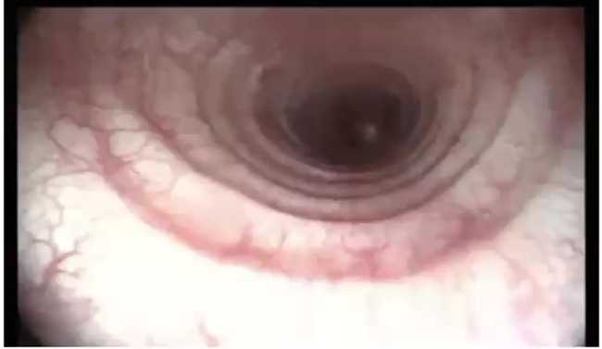
Tracheal view during bronchoscopy.
A. 12-o'clock
B. 3-o'clock
C. 6-o'clock
D. 9-o'clock
Correct answer: C. 6-o'clock

Answer explanation
In the tracheal image, the anterior aspect corresponds to 6-o'clock. The key landmark is tracheal structure: C-shaped cartilaginous rings form the anterior and lateral walls, while the posterior wall is membranous and contains the trachealis muscle.
Here, the posterior membranous wall is oriented toward the top of the endoscopic field. The opposite side of the lumen, at the lower part of the image, therefore represents the anterior trachea.
Bronchoscopic orientation changes with patient position, head rotation, and scope torque. Rather than assuming the top of the screen is anterior, the operator should repeatedly identify cartilage rings, the membranous wall, and branch anatomy before describing lesions or navigating.
This principle also helps when documenting airway abnormalities. A lesion described as anterior, posterior, right lateral, or left lateral should be based on airway landmarks (and, thus, the patient’s position), not the operator's hand position or a rotated video image. Re-checking landmarks before biopsy, dilation, or stent planning reduces incorrect localization and management.

Question 11
A balloon blocker is placed for recurrent and persistent massive right lower lobe bronchopulmonary hemorrhage related to chronic bronchiectasis. The patient is stabilized, deeply sedated, and paralyzed in the ICU, with peak airway pressure 30-35 cm H2O. During preparation for transfer to interventional radiology (IR) for bronchial artery embolization, there is a sudden increase of peak airway pressure and loss of tidal volume. Which of the following should be performed next?
A. Further inflate the endotracheal tube (ETT) cuff
B. Further inflate the balloon blocker
C. Emergent left chest tube placement
D. Bedside bronchoscopy
Correct answer: D. Bedside bronchoscopy

Answer explanation
A sudden rise in peak pressure with loss of tidal volume points toward increased resistance to gas delivery, either in the airway (including vent circuit) or the lung, resulting in premature termination of the breath after reaching preset ‘alarm’ values. A patient with a balloon blocker placed for massive active bronchopulmonary hemorrhage requires careful monitoring that might suggest malfunction of the blocker. The blocker could migrate proximally or deflate. In the former scenario, the blocker can lead to large airway or even endotracheal tube obstruction. Blockers may change position either due to patient movements (important to maintain paralysis), or changes in position of either the blocker itself or the ETT to which it is secured. Balloon deflation may permit ongoing hemorrhage to cause airway flooding and secondary obstruction from clot formation. All these mishaps would result in the physiology described. Because the patient is paralyzed, coughing or ventilator dyssynchrony is unlikely to explain the abrupt change. To properly and rapidly diagnose and manage a potentially catastrophic clinical development, an emergent bedside bronchoscopy is warranted. Single-use bronchoscopes, which are readily available in many modern ICUs, are a good choice in this situation.
Inflating the ETT cuff is not necessary as an ETT leak would cause a drop, not rise, in airway pressures. Further inflating of the balloon blocker may ultimately be necessary, but only after a deflation has been diagnosed and airway flooding by ongoing hemorrhage ruled out. If a migration is the problem, inappropriate blocker overinflation would potentially exacerbate, not solve the situation. A contralateral pneumothorax is possible given preferential gas delivery to the opposite, healthy lung. However, a balloon malfunction is more likely, and an accurate diagnosis is critical before empiric chest tube placement.

Question 12
In which of the following scenarios is bronchoalveolar lavage (BAL) MOST helpful?
A. A patient with poor dentition, frequent aspiration, general malaise, and a right lower lobe consolidation
B. A patient with AIDS, dry cough and dyspnea for 3 weeks, and bilateral ground-glass lung opacities
C. A patient with a 100 pack-year smoking history and a slowly growing 18 mm part-solid right lung nodule
D. A patient with 3 days of pharyngitis, cough, rhinorrhea, and low-grade fever
Correct answer: B. A patient with AIDS, dry cough and dyspnea for 3 weeks, and bilateral ground-glass lung opacities

Answer explanation
Bronchoscopy with BAL is most helpful when it will more efficiently identify infection or an alternative diagnosis over other available methods. AIDS with subacute dry cough, dyspnea, and bilateral ground-glass opacities is a classic presentation of Pneumocystis jirovecii pneumonia. BAL performs very well in this clinical context, and the patient’s dry cough is less likely to yield a diagnosis via sputum sampling.
Aspiration pneumonia in a patient with poor dentition is often treated empirically, and BAL is of limited added value. A slowly growing part-solid nodule requires tissue diagnosis to rule out cancer, for which BAL is a poor choice due to low yield. Short-duration pharyngitis, cough, rhinorrhea, and low-grade fever suggest an uncomplicated viral upper respiratory infection, where invasive sampling is not justified.

Question 13
Which of the following best describes the airway mucosa shown below?
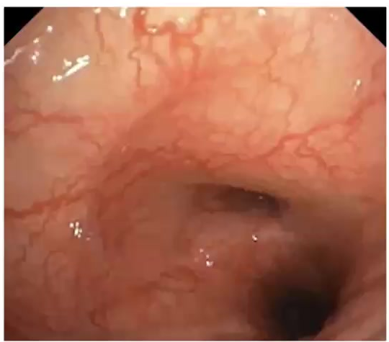
Bronchoscopic mucosal appearance.
A. Normal
B. Nodular and ulcerated
C. Edematous and hypervascular
D. Exudative and necrotic
Correct answer: C. Edematous and hypervascular

Answer explanation
The image shows swollen, erythematous mucosa with prominent superficial blood vessels. Those visual findings are best described as edematous and hypervascular. Edematous hypervascular mucosa may reflect inflammation, infection, edema, vascular congestion, or malignant infiltration. The bronchoscopist should document the location and distribution of the findings and avoid unnecessary trauma during inspection, as such mucosa is often friable.
Nodular mucosa will be raised and ‘bumpy’, ulcerated mucosa will have mucosal breaks often with a pale-white base which may easily bleed, exudates and necrosis will demonstrate purulence, often manifest as dark tissue, sometimes with sloughing.

Question 14
Which of the following is CORRECT about bronchoscopic diagnostic sampling tools and techniques?
A. Forceps biopsy-obtained tissue can be placed in saline to evaluate for infection
B. Bronchial brushings are an effective tool for peribronchial lymph node sampling
C. Bronchoalveolar lavage has a pneumothorax risk of about 1-5%
D. Transbronchial needle aspiration is primarily used for sampling peripheral lung nodules
Correct answer: A. Forceps biopsy-obtained tissue can be placed in saline to evaluate for infection

Answer explanation
Forceps biopsy tissue can be placed in sterile saline when infection is part of the differential diagnosis. Saline preserves tissue for microbiology. Formalin is used for histopathology but kills bacteria and thus prevents culture, so specimen handling must match the intended test.
Bronchial brushings are useful for mucosal or visible endobronchial abnormalities, but they do not traverse the airway and sample peribronchial lymph nodes. Nodes are accessed with transbronchial needle aspiration, often guided by convex-probe EBUS, a very common procedure and the guideline-directed choice for mediastinal staging in suspected lung cancer. BAL itself has very low pneumothorax risk; that risk is more associated with transbronchial lung biopsy.

Question 15
A bronchoalveolar lavage is performed in a patient with diffuse parenchymal lung disease. The anterior segment of the right upper lobe is chosen and a good wedge obtained. After instillation of a 60 ml aliquot of sterile saline, 30 ml of fluid is recovered. What is the MOST APPROPRIATE next step in the procedure?
A. Move the bronchoscope to the middle lobe and perform a lavage there
B. Maintain wedge and instill an additional 40 ml sterile saline
C. Maintain wedge, position the patient in left lateral decubitus and slight Trendelenburg, and continue fluid aspiration
D. Conclude the procedure as you have adequate fluid recovery
Correct answer: B. Maintain wedge and instill an additional 40 ml sterile saline

Answer explanation
BAL technique should minimize proximal airway contamination by avoiding suctioning while maneuvering to the target airway, and then maintaining a good wedge in the selected airway. A 60 ml aliquot with 30 ml recovery is a good first return, but it is not yet a complete lavage. Adequate lavage volume requires instilling 100-300 ml total, divided into several aliquots of about 50-100 ml, to ensure adequate peripheral reach and robust alveolar sampling. Therefore, the next step is to maintain the wedge and instill additional sterile saline.
Moving to another lobe introduces a new site, increasing contamination risk and is unnecessary for diffuse disease. Positioning maneuvers may be useful when return is poor, which is not the case in this stem. Concluding early would sacrifice diagnostic yield and standardization.

